JillianHanna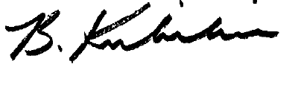Stroke LogoStroke Logo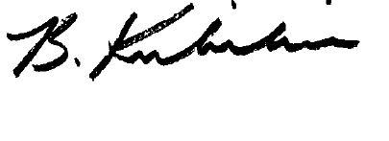



Barbra Kubilius, Regional Stroke Education Coordinator

Central South Regional Stroke Program

**Certificate of Completion**  
is hereby granted to

to certify that he/she has completed the  
Integrating Motor Learning Strategies into Task Oriented Rehabilitation After Stroke

on

February 23rd, 2021

Hamilton, Ontario

3.5 hours of continuing education

